It is great that you are looking in studying Mathematics in Sixth Form and I hope this is useful for you.

We have put together some bridging work you to best prepare you for A-Level Mathematics.

This work will prepare you, so you don’t find the jump from school to Sixth Form as difficult.

Mathematical Studies – (Need a grade 4 in Maths)
- There are some key topics that you would have covered at GCSE that will be used throughout the course. I suggest working your way through these and becoming secure in these areas. This will form the baseline assessment in the first couple of weeks.

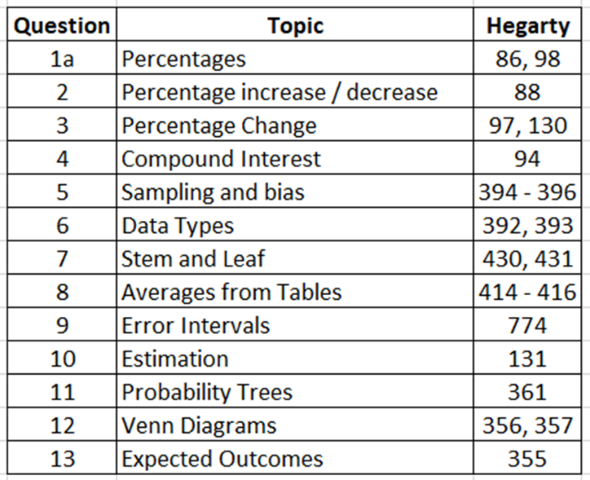

Any questions then please do email me.

Thanks
Mr Forsyth

